Coral Bleaching Protocol
Overall Objective
The aim of this protocol is to monitor the severity of bleaching events and the recovery potential following bleaching events by surveying coral populations at different depths on the reef. Depending on your time you want to invest and your knowledge of coral taxonomy you can choose option A OR B

Option A – Belt transect
This option is recommended for observers with good knowledge of coral genera existing in Maldives. This option is quite time consuming and therefore requires enough time to conduct the surveys. The estimated time to do one transect (10m) depends on the coral cover present at the site, but it can typically range from 20 – 30 minutes per 10m transect.
Objective
Survey coral bleaching in each reef habitat: on the reef flat (~1 m), reef crest (~5 m), reef slope (~10 m) and vertical slope (~10 m). If you can only do 1 habitat then survey corals on the reef crest (~5 m).
Suggested equipment
Protocol forms, pencils, Perspex or other u/w slate or clipboard, rubber bands,
50 m transect tape, species ID guides, snorkeling or SCUBA gear and associated safety equipment, sunscreen and/or protective clothing, a safety plan and these instructions.
Suggested Frequency
Twice-yearly in case of no bleaching.
In case of a bleaching event, survey the reef once before the predicted bleaching event, then during the bleaching event every 1-2 weeks (if possible), and then every month following the bleaching event (if possible) to monitor recovery.
Notes
A minimum of three transects should be completed at each of the three depths at the established permanent marker locations. If you set up additional sites with three transects at each of the three depths, then you should complete all surveys within the space of a week.
Instructions
Lay a transect tape at the selected depth parallel to the beach and survey all
the corals present in three consecutive 10 by 1 m transects. Leave a gap of
~3m between each transect. Always survey a minimum of three consecutive transects for statistical comparisons.

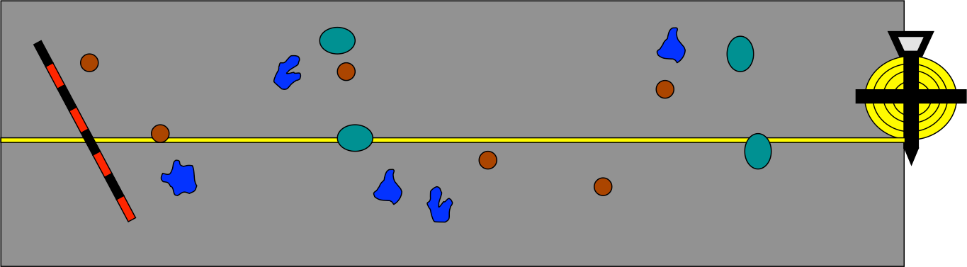

For each belt transect, count all the coral colonies, identify them by genus and record the extent of bleaching per colony using these six categories (from Gleason 1993):

- No bleaching
- 1-10% of the colony is bleached
- 11-50% of the colony is bleached
- 51-99% of the colony is bleached
- 100% bleached
- Dead

At each reef where you lay your three transects, please complete the required fields, entering the reef- and dive site name that is commonly used in the area, the time, atoll, latitude and longitude, water temperature, depth, visibility, and reef habitat.

It is also important to record whether there are additional stressors visible or in the vicinity such as sedimentation, macro algae, cyanobacteria, near a sewage treatment plant, etc.

Write in the start time of the survey, the site ID, the direction of the transect in compass degrees, and your 'Observer ID' on the protocol datasheet. Write the survey method as one of these: Scuba or Snorkel.
Below is an example of a data sheet that you could use to enter the data. The rows show 3 transects, with the most commonly found coral genera under each transect. Additional genera encountered can be added in the blank rows. A mark for each coral denoting bleaching severity can then be made in the appropriate column.

Data sheet (option a - belt transect)

Site: |  |  |  |  | Observer:
Date: |  |  |  |  | Depth:
Transect |  | Bleaching Severity
 | Genera | 1 | 2 | 3 | 4 | 5 | 6
1 | Acropora
 | Favia
 | Favites
 | Goniastrea
 | Leptoseris
 | Montipora
 | Pavona
 | Pocillopora
 | Porites
 | Psammocora
2 | Acropora
 | Favia
 | Favites
 | Goniastrea
 | Leptoseris
 | Montipora
 | Pavona
 | Pocillopora
 | Porites
 | Psammocora
3 | Acropora
 | Favia
 | Favites
 | Goniastrea
 | Leptoseris
 | Montipora
 | Pavona
 | Pocillopora
 | Porites
 | Psammocora

Instructions:
Fill the collected data into the colored fields and send to, or request the Excel sheets to fill in from the following people:
Nizam Ibrahim: nibrahim@mrc.gov.mv
And copy Ahmed Basheer: ahmed.bashyr@gmail.com

How to identify bleaching during a mass bleaching event?

Mass coral bleaching is visually very distinctive, but determining whether bleaching or some other stress is affecting individual corals can sometimes be difficult. See the photos on the next page: (a) Bleaching is usually distinguished by the way it affects entire colonies or large sections of colonies similarly. Sometimes coral tissue and polyps can still be seen remaining on the skeletons as the coral is still alive. The effects of coral predators, such as
(b) crown-of-thorns starfish and (c) drupella snails can often be recognized by patches of bare skeleton adjoining patches of live, healthy tissue. (d) Coral diseases can also be sometimes mistaken for the early stages of mass coral bleaching. Disease takes many forms, but the effects of disease are often characterized by a strong line separating live and
dead parts of a coral, or by rapid erosion of the surface structure of the coral, as shown here (Marshall, Paul, 1969 “A reef manager’s guide to coral bleaching”).

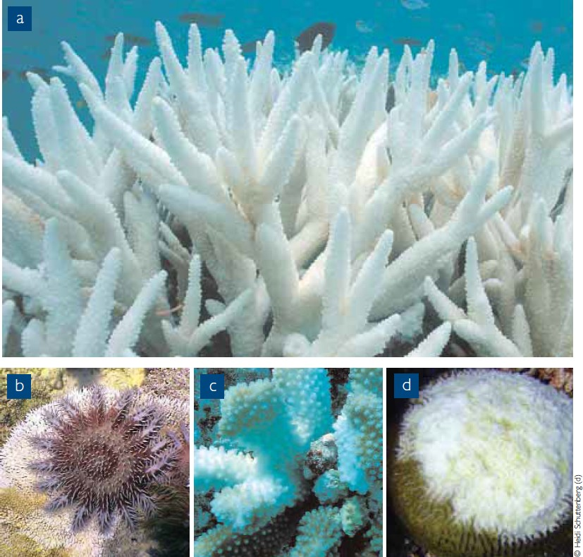

White tips
Branching and plating corals (for example Acropora species) appear to have white tips although the rest of the colony seems to be intense in color. In this case, it is part of the growing process of a healthy coral.

A healthy, branching coral (Acropora sp.) displaying white tips.
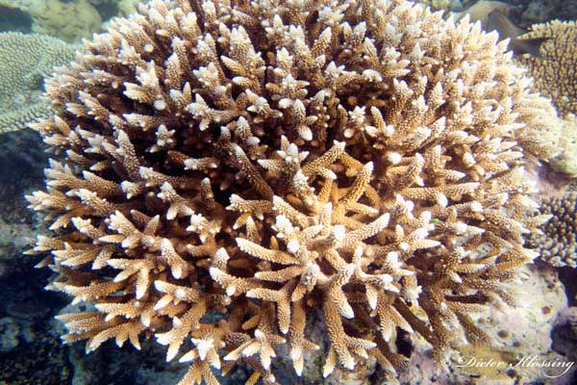
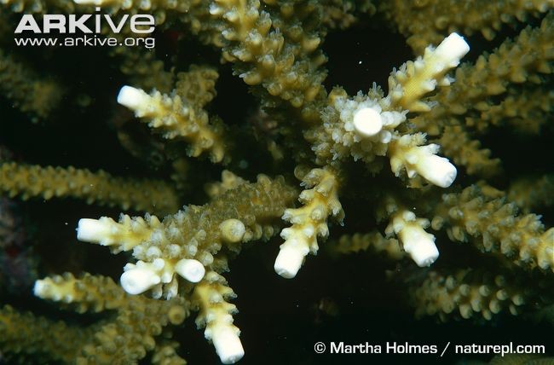
A branching coral (Acropora sp.) displaying white tips as part of a natural growing process. These corals are not bleached.

For more information, see the links below

Facts about coral bleaching: http://oceanservice.noaa.gov/facts/coral_bleach.html

Snails feeding on coral polyps: http://www.reefresilience.org/coral-reefs/stressors/predator- outbreaks/drupella/

Crown of thorn starfish:
http://www.reefresilience.org/coral-reefs/stressors/predator-outbreaks/crown- of-thorns-starfish/

Coral disease:
http://www.reefresilience.org/coral-reefs/stressors/coral-disease/

